Step-NC in 60 Seconds
December 9, 2008

STEP-NC ISO Numerology
This paper gives an overview of STEP-NC and comments on its untapped potential. Those familiar with CAM programming will understand the feature-based machining modeling of STEP-NC. Clearly, the natural evolution for CNC technology is for more and more CAM functionality to be incorporated into the machine tool, especially since the CNC has a native understanding of the machine dynamics and control/trajectory algorithms of the machine and can theoretically better meet tolerance and surface finishes with faster cycle times. At the end of the document is a discussion on the unlimited possibilities of push-button CNC is given.

As a point of confusion, multiple ISO standards are referred to colloquially as STEP-NC. STEP-NC is defined as either ISO 14649 or as ISO 10303-AP238. For this discussion, STEP-NC is described by ISO 14649 Parts 10 (general machining), Part 11 (milling), Part 12 (turning), Part 110 (tooling), etc. All parts of ISO 14649 are specified as information model schemas written in the STEP language Express (ISO 10303-11).

Part 21
STEP Part 21 is the format STEP-NC data is exchanged. Below is a condensed Part21 containing a header, and only describing a security plane. The Part 21 product data is described as a list of #n= fcn(…) statements. Each #n defines a STEPNC instance. The fcn defines the “entity” name (equivalent to an OO class name) from either Part 10 or Part 11. The sequence of comma separated values between ()’s define the entity attributes. The value types can be: 1) simple, e.g., the string ‘Plane’, 2) list, e.g., (1,0,0) or 3) a # reference to another entity instance. In the line “#62 = PLANE…” instance 62 defines a Plane, with a simple ‘SECURITY PLANE’ string type, and uses data described in entity reference #73 which in turn references entities #98, #99, #100. In Part 21, entity names are capitalized.

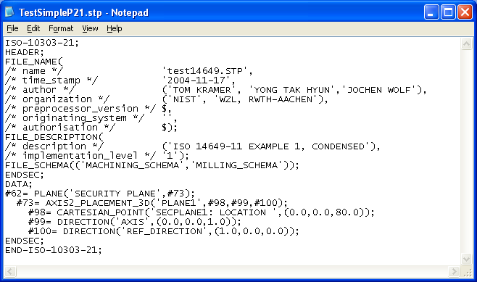
Figure 1 STEP-NC Part 21 Sample

STEP-NC Information Model
The STEP-NC information contains the information you would find defined by a CAM system – workpiece, setup, geometry, features, operations, tools, materials, etc.

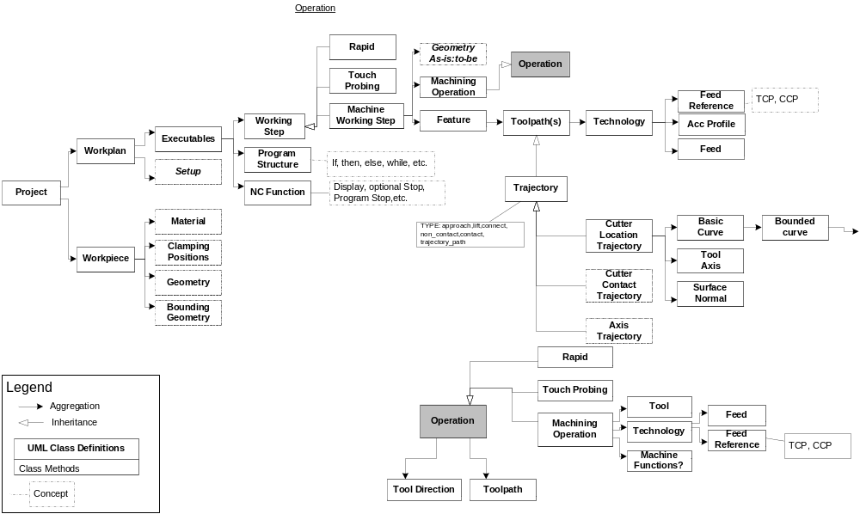
Figure 2 STEP-NC Info Model – High-Level

Figure 2 shows a UML representation of the high-level machining STEP NC information model,s which is based on an object-oriented (OO) modular design with object definitions that encapsulate attributes (but not methods). In OO design, complex classes are built using either inheritance or composition of subclasses. OO aggregation is a type of composition where the complex object has a reference to the subobject. OO inheritance creates new classes by directly acquiring the attributes and methods of other objects and then extending or specializing them.

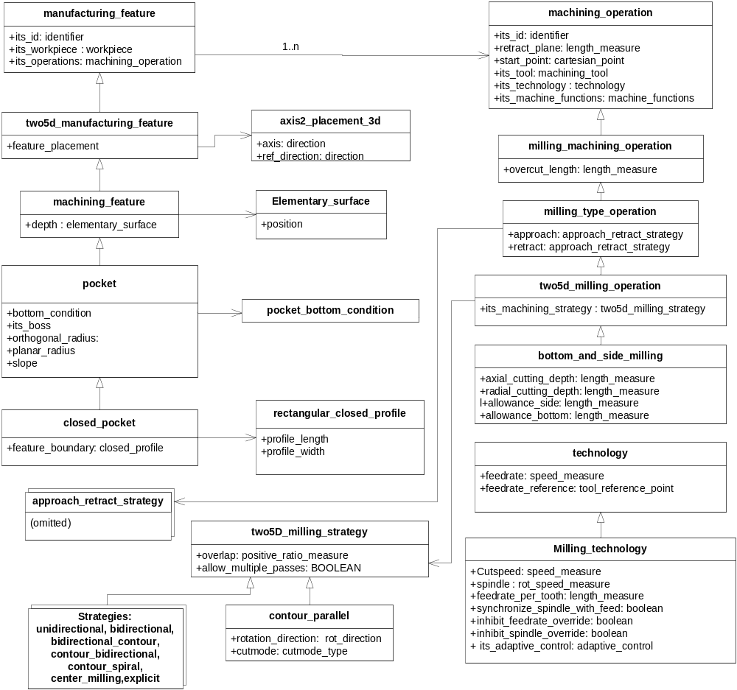
Figure 3 STEP-NC Pocket Information Model

Let’s look at how a rectangular pocket is represented in STEP-NC. Figure 2 shows a UML representation of the STEP-NC information model for a defining rectangular pocket by first defining a closed_pocket, which inherits attributes from pocket which inherits from a machining_feature, which inherits from two5d_manufacturing_feature, which inherits from manufacturing_feature. To distinguish a closed rectangular pocket from a closed circular pocket, closed_pocket shows an aggregation reference to the rectangular_closed_profile which contains attributes for length and width. The pocket feature uses a side/bottom machining_operation to describe the pocketing operation tool, feed, speed parameters.

Table 1 STEP-NC CNC Pocket Mapping
Pocket Parameters | STEP-NC Pocketing Parameters
Retract Plane | "MillingOp"/retract_plane
Reference Plane – i.e. top of pocket | its_feature/feature_placement/location/coordinates[z]
Safety Clearance Plane | Hard coded as 2 mm
Absolute Depth  (Relative Depth available - not used) | its_feature/depth/position/location/coordinates[z]
Length | its_feature/feature_boundary/profile_length/theoretical_size
Width | its_feature/feature_boundary/profile_width/theoretical_size
Center Abscissa | its_feature/feature_placement/location/coordinates[x]
Center Ordinate | its_feature/feature_placement/location/coordinates[y]
Corner Radius | its_feature/orthogonal_radius/theoretical_size
Rotation Angle | Angle between longitudinal axis and abscissa.  Computed using: its_feature/feature_placement/ref_direction/direction_ratios
CycleType:  Roughing, Finishing, Combination | Use classname of /its_feature/its_operations[i] to derive rough or finish
Feedrate for depth infeed | Not addressed in approach_retract_strategy
MillingDirection:  climb vs conventional | "MillingOp"/its_machining_strategy/cutmode  Assuming contour_parallel machining strategy.  STEP-NC default is conventional.
Not used. | Stepover
Finish Feed | "MillingOp"/its_technology/feedrate  In: technology, (requires units conversion)
Finish Speed | "MillingOp"/its_technology/spindle  In: milling_technology
Feedrate | Feedrate for surface machining  "MillingOp"/its_technology/feedrate  In: technology, (requires units conversion)
Spindle Speed | "MillingOp"/its_technology/spindle  In: milling_technology
Spindle Direction | "MillingOp"/its_technology/spindle sign
Tool Type | Classname of “MillingOp"/its_tool/its_tool_body
Tool Radius | "MillingOp"/its_tool_body/dimension/diameter
Finish Allowance Side (for roughing) | "MillingOp"/allowance_side
Finish Allowance Bottom(for roughing) | "MillingOp"/allowance_bottom
Max One Infeed Depth | "MillingOp"/axial_cutting_depth

Table 1 shows the mapping from STEP-NC data representation into CNC pocketing terminology. In the table, “its_feature” refers to the closed_pocket class. “MillingOp” refers to a milling operation done by traversing from the feature to the “bottom_side_milling” operation.

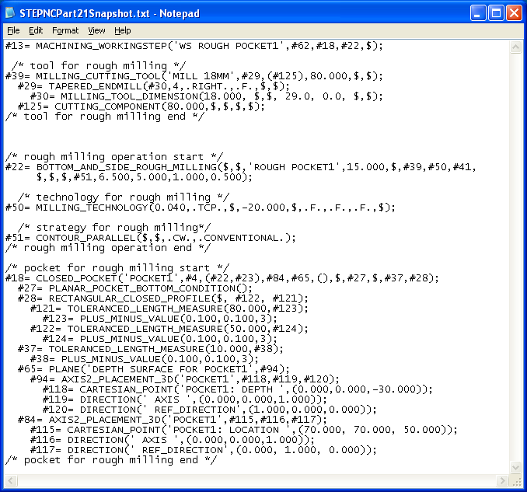
Figure 4 Part21 Pocketing Sample

Figure 4 shows a Part21 representation for rough pocket machining_workingstep. The tool is tapered endmill with dimensions (MILLING_TOOL_DIMENSIONS) and cutter definition (CUTTING_COMPONENT). Milling_technology defines the cutting speed of the tool, the speed and rotational of the spindle, and federate per tooth. Tool movement within the machining_operation, (unless defined by an explicit toolpath – which is not the case here), is determined by the technology-dependent strategy such as zig-zag, contour, etc. The TOLERANCED_LEGNTH_MEASURE is used to define tolerances on various pocket elements.

Discussion
STEP-NC offers a number of potential manufacturing advantages. Foremost, STEP-NC contains a comprehensive model that describes complete process and machining data that can be made available to the CNC machine tool. STEP-NC allows for better vertical integration between CAD/CAM and CNC with a full complement of production knowledge such as tooling, stock, materials, and setup. STEP-NC can resolve today’s CAM/CNC impedance mismatch where RS274 program exchange reduces comprehensive CAM process information into CNC motion primitives. Mitigating the potential benefits of using STEP-NC is the fact that no CAM or CNC vendors provide native STEP-NC support. Numerous attempts to demonstrate and promote STEP-NC as the next Holy Grail have not gained traction. A few compelling benefits will be discussed.

The key for STEP-NC adoption is leveraging the existing CNC smarts that go unused or are impossibly difficult to program using CAM/RS274. The sum effect is that existing CAM programming and part fabrication is based on worst-case modeling, trial-and-error, or linear approximations of desired machining behavior. Instead, CNC bring a much better understanding of the machine dynamics, motion trajectories and lastly, part quality as the machine probing for on-machine part acceptance is emerging. STEPNC feature-based process descriptions would allow CNCs to perform adaptive-control, tolerance-based machining to improve finishing accuracies and roughing cycle times. Given a STEPNC tool and material descriptions, the CNC could do self-tuning adaptive control based on regulating spindle power and the process characteristics. These are just some of the embryonic functionality possible in an STEP-NC empowered CNC world. Consequently, elevating the mantle of STEP-NC and intelligent CNC machining in general, should be a top priority to all manufacturing practitioners.

Comments or Questions
If you have a comment or question please contact John Michaloski, NIST, 301-975-3458, john.michaloski@nist.gov.

